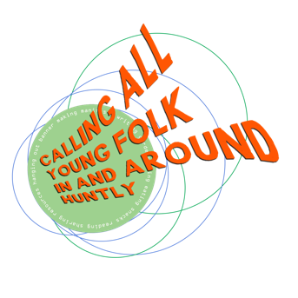
We are the
Huntly Youth Climate Warriors
This is our manifesto

- We demand that our voices are heard!
We want to be represented in councillor meetings, the Town Team and on the national and international stage. We will be bringing young people into the movement to show we mean business!

- We fight for breaking colonial chains!
We amplify the voices of those oppressed by colonialism, imperialism, racial capitalism, past and present , and especially those in the Global South who continue to be most affected by climate change.

- We protect our areas from polluters
We are like a barrier; if you want to pollute our area you have to cross us!

- End local reliance on fossil fuel!
We need more green energy urgently, such as wind turbines, electric charging points, a bike friendly town and no unnecessary big cars and SUVs. We demand that bureaucratic barriers to setting up sources of green energy are removed! Sign our anti-SUV petition!

- Increase biodiversity!
We advocate for cultivating biodiversity and new green spaces in our area. Many of our local species are becoming endangered – like swifts. We want forest and bog regeneration on land cleared for grouse shooting. We want wildflower meadows for everyone, not golf courses for the super rich.

- We will fight alongside workers in the oil and gas industries for a just transition. Fossil capital maximises its profit as the world burns. We will fight tactics of ‘greenwashing’ used by them to keep people passive. Don’t do internships at Shell!

- Public transport must be improved!
We need better buses and trains, affordable fares for everyone and a well connected transport network. Stagecoach, we’re coming for you!

- We stand in solidarity with Friday School Strikes
Remove the stigma from young people who want to go on climate strike! Every young person has power and the right for a future.

